1. Outlier Detection:

Table - leads_basic_details :

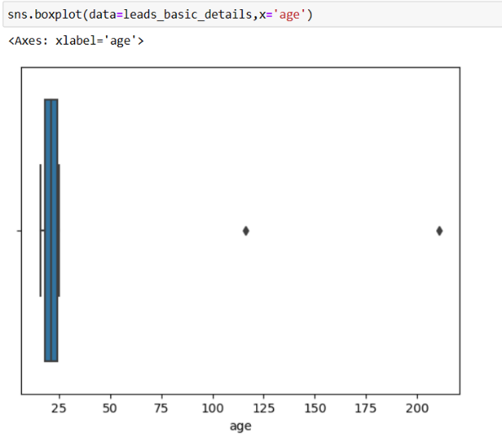

In this I create a boxplot and found out 2 outliers in age columns

1. 211
2. 116

This is the Record => 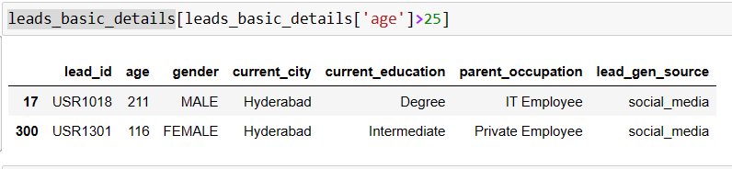

Table - leads_demo_watched_details :

In this columns has two outliers

1.510

2.233

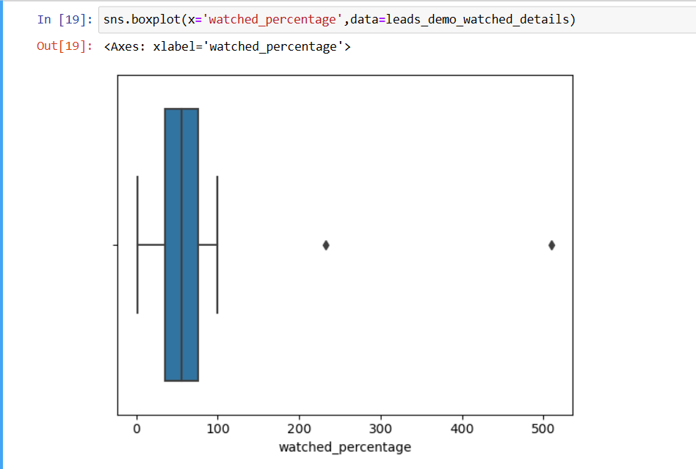

Records are => 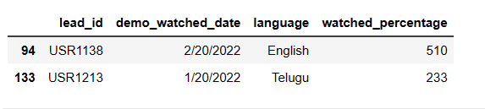

Rather than this everything is fine now move to the visualization part in Power BI .